Klaus chardt <Author

Week 17

Plan

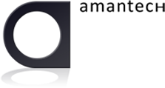

|  |  |
| --- | --- |
| Current Version: | 1.0 |
| Version Date: | 11-04-2012 |
| Status | Draft |
| Author: | Mikael Floberg |

Table of Contents

Commercial in Confidence © Högskolan på Gotland

1. Document Control 3

2. Vecka 17 - Cloud App Studio – Android app 4

# Document Control

|  |  |  |  |
| --- | --- | --- | --- |
| **Version** | **Date** | **Comment** | **Editor** |
| 1.0 | 110412 | First Draft created | Mikael Floberg |

# Vecka 17 - Cloud App Studio – Android app

Vecka 17 skapar ni en smakfull native Android-app som läser in och visar datat/informationen via JSON-apit?

Servern är <https://cloudappstudio360.appspot.com>.